1. **Understanding data and background**

<https://www.kaggle.com/competitions/lish-moa/discussion/184005>

We have been given data collected from a cell-based assay which records levels of gene expression and cell viability. Our objective is to use the patterns in this data to predict the mechanism of action (MoA) of a drug. This is a multi-label competition where some rows can be linked to multiple targets, instead of multi-class. The data comprises of 772 gene expression features labeled as "g-" that represent the expression of one specific gene, and 100 cell viability features labeled as "c-" that represent the viability of one particular cell line. The original data was normalized using [quantile normalization](https://www.youtube.com/watch?v=ecjN6Xpv6SE&ab_channel=StatQuestwithJoshStarmer).

1. **EDA**

The majority of the treatments in the dataset are compound treatments (referred to as "trt_cp"), while only around 8% are control perturbation treatments (referred to as "ctl_vehicle"). The controls do not have any Mechanisms of Action (MoAs).

The "cp_vehicle" column distinguishes between treatment (with drugs) and control (without drugs) experiments. DMSO is a common control vehicle that is unlikely to have any significant biological effects. We can use the control data as negative samples during training or normalize the treatment features.

Timing - The cp_time column indicates the amount of time elapsed between adding the drug and when the measurement was taken. The effect this has on the data will differ depending on the mechanism. For example, some drugs will have an irreversible effect that can still be seen 72 hours after dosing. Other drugs will have lost all effect by that point and may be indistinguishable from controls.

Dosage - The cp_dose column indicates the dose level used in the experiment. Generally a higher dose will have a stronger effect.

All the targets are binary columns, indicating whether a certain cell type responds to the drug, or not. Some target classes also measure the type of response; e.g. there is an “adrenergic_receptor_agonist” class and an “adrenergic_receptor_antagonist” class. Those should probably not be active for the same sample row.

Our challenge is a multi-label classification problem, and as such the rows (i.e. drug samples) can have multiple MoA’s (i.e. more than one target class can be active).

About 39% of training samples have no MoA annotations at all (e.g. all the target classes have values of zero). This goes a certain way to explain the sparse target dataframe, if 40% of it are completely empty, these are controlled perturbations ([here](https://www.kaggle.com/c/lish-moa/discussion/180304)).

The largest group, with a bit more than 50% of samples, has exactly 1 MoA annotation (e.g. one class = one value of “1” in its row).

For more than 1 MoA annotation, we see a tail that extends down to 7 simultaneous MoAs (for 0.03% of cases). Only the case of 2 MoAs is just above 5%, and 3 MoAs is slighly above 1%. Every other case is significantly rarer. Note, that there is no instance with 6 MoAs.

It seems we have 2 outliers here: "nfkb_inhibitor” and “proteasome_inhibitor”.

Most of the targets have 0 correlation. It is worth recalling that the presence of active targets in the samples in very low (mainly 1 or 2 targets per sample).

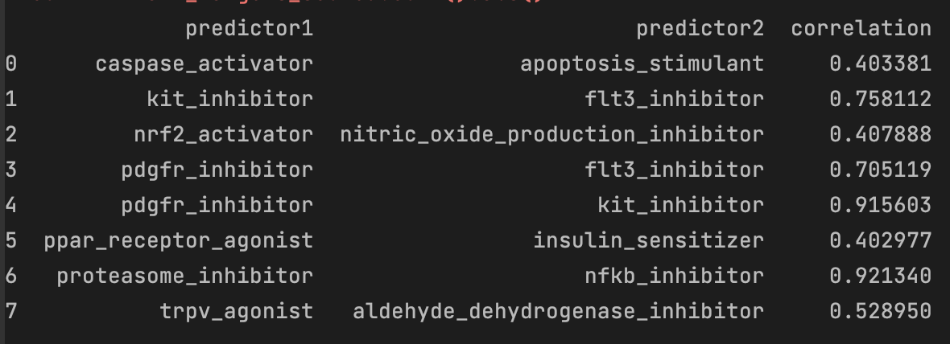However, we notice some yellow dots (high correlation) between some targets. Let's have a closer look over these targets.

Those target pairs must be in the few samples that have more than two active targets. The functionality of these targets and their distribution is something to be taken into consideration because in this case, we have a multi-label classification problem, where the correlation between the labels is also important and the model selection should be based on the labels correlation. Select a model that finds patterns not just in the train data but also in the multi-label target data.

1. **Loss Function**

<https://www.kaggle.com/competitions/lish-moa/discussion/182274>

For loss we are using log-loss also called logit loss which nothing but cross-entropy loss. Cross-entropy loss: measures the performance of a classification model whose output is a probability value between 0 and 1. The reason we used Cross-Entropy is that it measures the difference between two or more probability for a given random variable or set of events.

Accuracy refers to the number of times your predicted values match the actual values, but this metric is limited because it only provides a binary result (correct or incorrect). On the other hand, log loss considers the level of uncertainty in the prediction by measuring how much it deviates from the true label, providing a more detailed evaluation of the model's performance.

1. Modeling

<https://github.com/trent-b/iterative-stratification>

Variance thresholding: In multilabel classification, it is common for features to be highly correlated with each other, and therefore redundant in terms of the information they provide for the classification task. Removing features with low variance can help to reduce this redundancy, and also eliminate noise and irrelevant features that may negatively impact the performance of the model.

Batch normalization (BN) is a technique used in neural networks to normalize the inputs of each layer in a mini-batch during training. In a multilabel classification problem, BN can help to improve the performance of the model by reducing the internal covariate shift that can occur during training. The internal covariate shift is the phenomenon where the distribution of inputs to a layer changes during training due to the changing parameters of the previous layers. This can cause the model to take longer to converge or to overfit to the training data. BN addresses this problem by normalizing the inputs to each layer, which helps to keep the distribution of inputs consistent across layers and across training batches. This can lead to faster convergence and better generalization to new data.

PCA is essentially a rotation of the parameter space so that the new axes are orthogonal and align with the directions of maximum variance.

the correlation between the labels is also important and the model selection should be based on the labels correlation. Select a model that finds patterns not just in the train data but also in the multi-label target data.

**References:**

PCA: <https://www.kaggle.com/c/lish-moa/discussion/195888>

Loss: <https://www.kaggle.com/code/ikennaanigbogu/understanding-logloss/notebook>